Ideation Phase Empathize & Discover

Date | 2 March
Team ID
Project Name | Electricity Consumption Analysis
Maximum Marks | 4 Marks

Empathy Map Canvas: Electricity Consumption Dashboard Users
Think & Feel
- Users worry about the accuracy of electricity consumption data.
- They aspire to make informed, data-driven decisions for policy and planning.
- Major preoccupations include sustainability, cost efficiency, and meeting regulatory requirements.
Hear
- Analysts hear from colleagues about difficulties in accessing reliable datasets.
- Policy makers hear public demand for transparency and accountability.
- Influencers and industry experts emphasize the importance of renewable energy integration.
See
- Users see fragmented datasets across multiple government portals.
- They notice dashboards that are outdated or lack interactivity.
- They observe peers using advanced analytics tools and want similar capabilities.
Say & Do
- Analysts often say they need faster, cleaner insights.
- Policy makers publicly emphasize energy efficiency and sustainability goals.
- Users manually clean data, prepare reports, and share them in meetings.
Pain
- Difficulty in accessing centralized, reliable data.
- Time-consuming manual analysis.
- Frustration with outdated tools and poor visualization.
- Limited technical expertise among some stakeholders.
Gain
- Confidence in making policy decisions backed by data.
- Clear, interactive dashboards that save time.
- Ability to forecast demand and plan resources effectively.
- Improved collaboration across teams with shared insights.

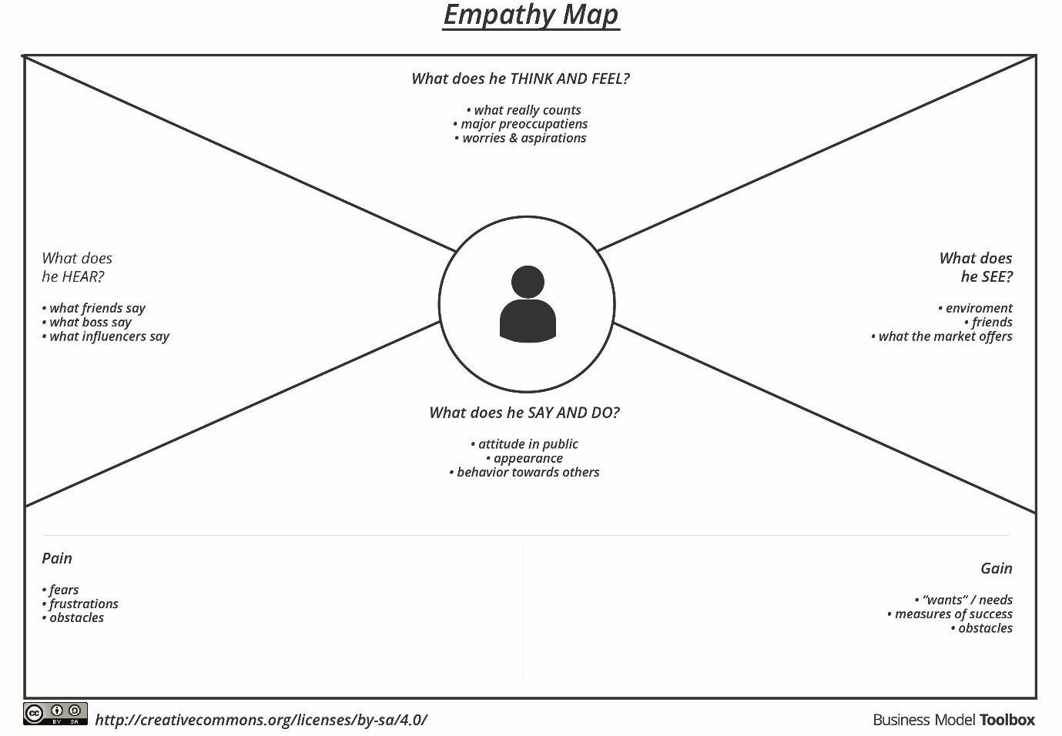
Example:

